Supplemental Release Notes for the Enterprise Quickstart + Zendesk Connector Virtual Appliance

This document describes the new features included in the Enterprise Quickstart + Zendesk Connector Virtual Appliance. This document supplements the Enterprise Quickstart SUSE-Powered Virtual Appliance release notes. New users should consult both documents before proceeding with installation.

## Contents

SECTION 1 – INSTALLATION

SECTION 2 - FEATURES

SECTION 3 – KNOWN ISSUES AND LIMITATIONS

## SECTION 1 – INSTALLATION

Download the virtual appliance package (zip) and the release notes from your account page.

**Installation**

Install the Virtual Appliance as described in virtual appliance release notes.

**Login Access to Portal**

The “admin” user is a specially privileged user. It is used in the creation of shared dashboards. The admin user, with the administrator role has access to all of the portlets. The Zendesk portlet is part of the administrator role. First login as the user ‘admin’ with default password ‘admin’ and changing the default admin password is highly recommended.

**Configuring Zendesk**

To install the Zendesk portlet application, the administrator must have a registered Zendesk account. If you do not have a zendesk account, you can obtain one by logging in to the GroundWork portal as the admin user and following the new account sign-up link. A new pop up window will appear to create your Zendesk account.

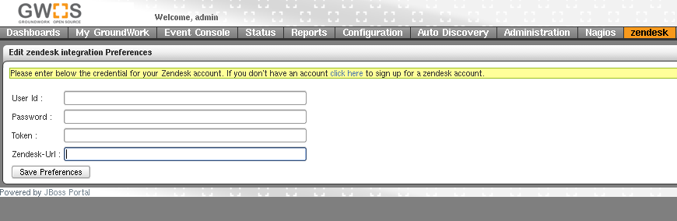

After filling out the web forms the zendesk credentials will be generated. The credentials will include a username, password and zendesk URL. Please make a note of them as they will needed later to configure the Zendesk integration in the GroundWork server. This is an example of the Zendesk Home page after successfully completing the account set up:

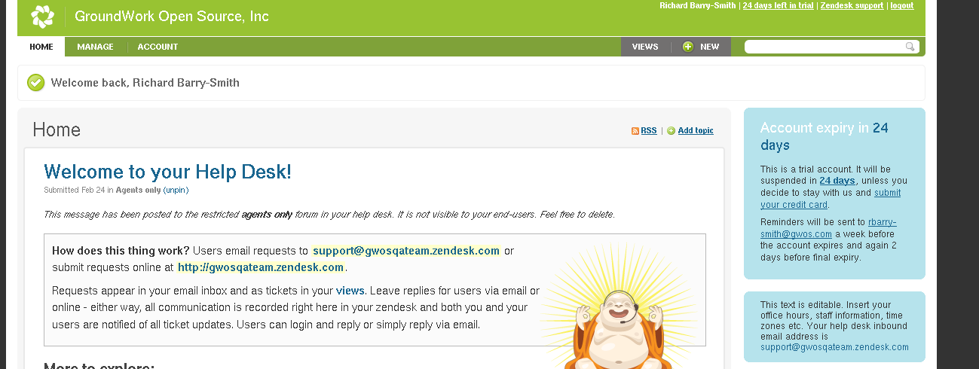

In order to provide single sign-on between Zendesk and GroundWork Monitor an authentication token must be generated. This is configured in the Zendesk application by navigating to the Account -> Integrations menu item.

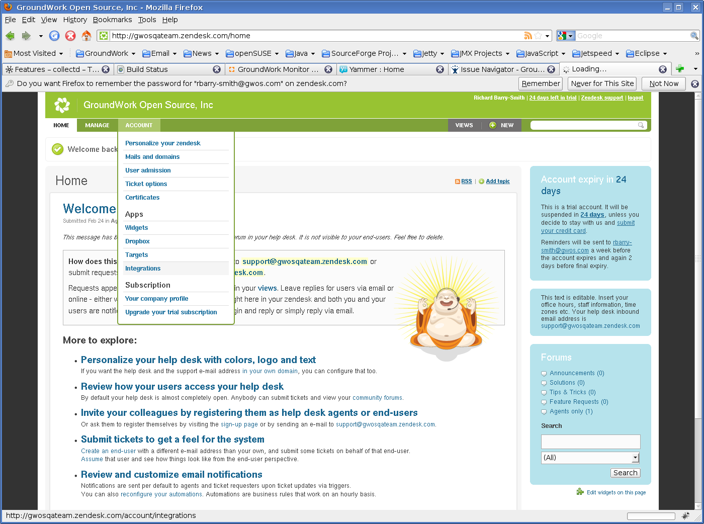

Now select the Inactive Integrations link:

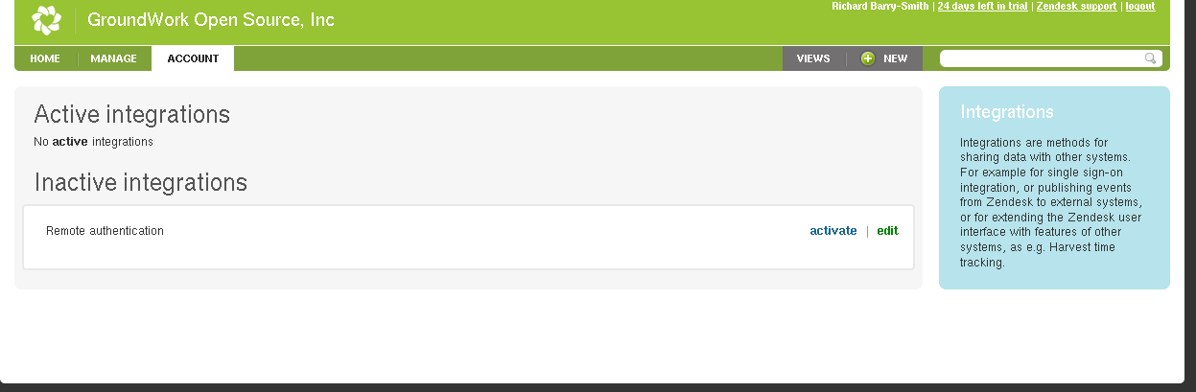

Complete the integrations form as shown below, substituting your helpdesk name and ip addresses as needed. Copy the authentication token value to the clipboard – we’ll need it later to configure GroundWork Monitor.

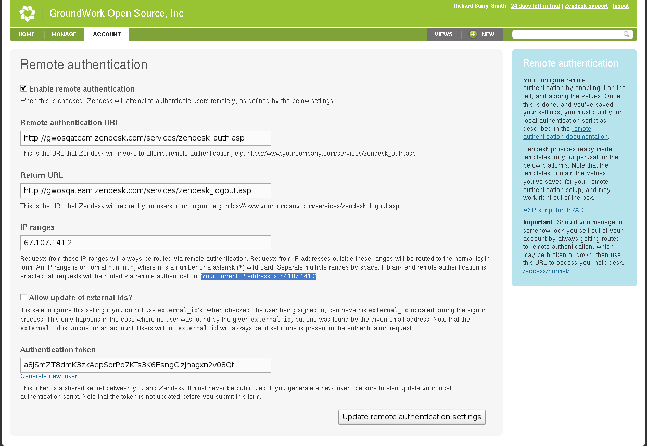

Once this process is completed, select the Zendesk tab in the GroundWork Monitor application and provide the Zendesk credentials including the authentication token from the previous step. 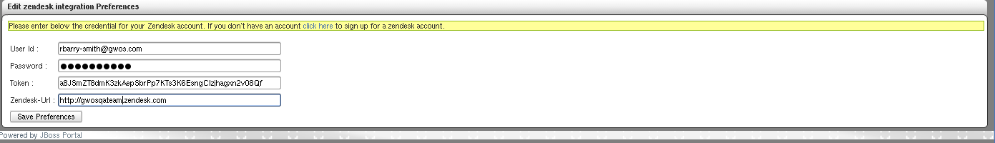

Press the save preferences button. This completes the configuration process. The helpdesk homepage will now appear in the Groundwork Monitor portal.

## SECTION 2 – FEATURES

The virtual appliance provides multiple connections between the monitoring dashboards and the Zendesk helpdesk. The following key features are provided out-of-the-box.

**Creating a Help Desk Ticket**

Helpdesk tickets can be created from the event console for all application types (Nagios, Syslog, SNMPTRAP and System.) To generate a Help Desk Ticket:

1. Select the Event Console application
2. Select a CRITICAL or DOWN event in the All Open Events tab.
3. Press the Actions button and select “Create a HelpDesk Ticket”

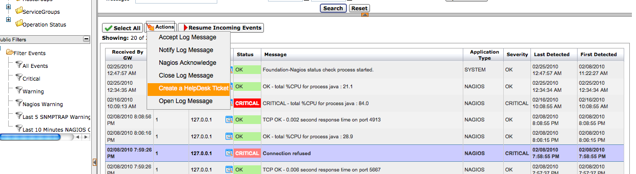

In order to verify the created ticket, click on the “OPEN TICKET” public filter in the left hand tree for the application type selected. When viewed through the filter the “TicketNo” and “Operator” fields are populated with the Zendesk ticket number and creating user are set.

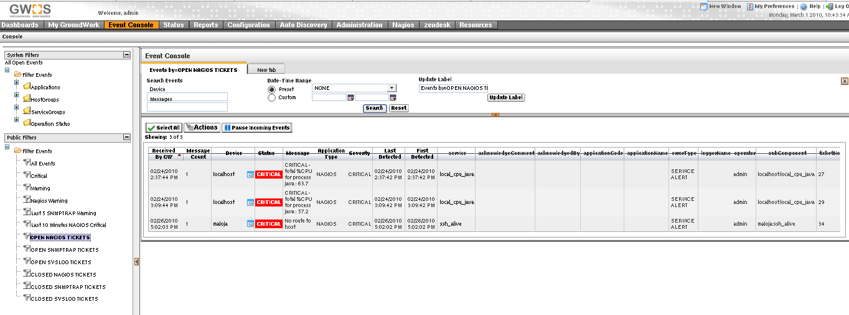

Identical features are included in the status viewer event console:

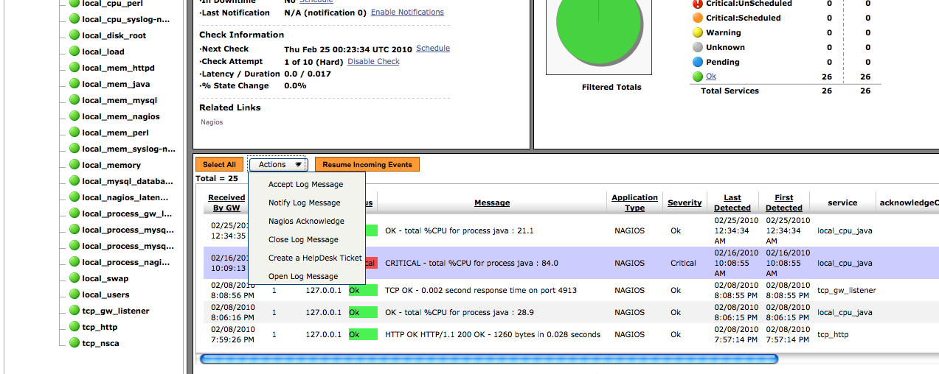

**Viewing the Help Desk Tickets in Zendesk**

To find tickets in the Zendesk helpdesk click on the Zendesk tab and select either the “Recent” or “Views” tab. The ticket includes a URL link back to the affected device or service in the GroundWork status viewer.

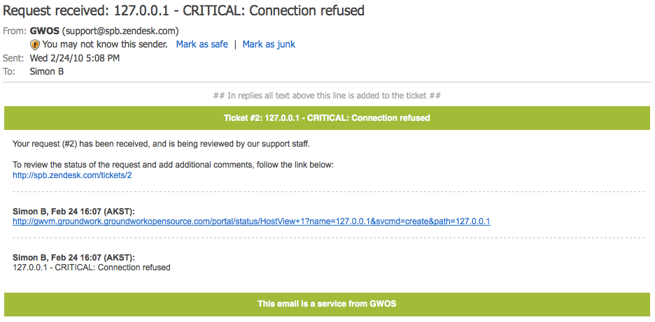

**Viewing Help Desk Tickets in GroundWork**

In order to close tickets in the Zendesk application, the admin must select the Solved status from the Status dropdown. This will move the state of the ticket to “Solved” in Zendesk. The Events associated to the ticket in GroundWork will be moved to CLOSED state. Zendesk by default will close solved tickets after a configurable period of time. Once the ticket is closed, the event will appear in the Event Console under the CLOSED TICKET Public Filter. Below is a view of the CLOSED filter.

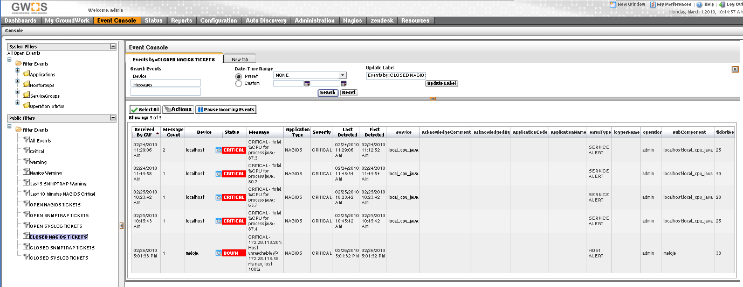

**Automatically acknowledging events when tickets are closed**

We suggest events be automatically acknowledged when the related ticket is closed. This ensures all events are acknowledged and consistency between the ticketing and monitoring system is maintained. By default tickets marked as resolved are closed after 4 days (96 hours) we suggest this be reduced:

From the Zendesk menu select Manage -> Automations link under the Business Rules.

Edit the title, “Close ticket 4 days after status is set to solved” to a title that represents your environment.

Press the edit option in the UI and change the business rules to a time that meets your environment.

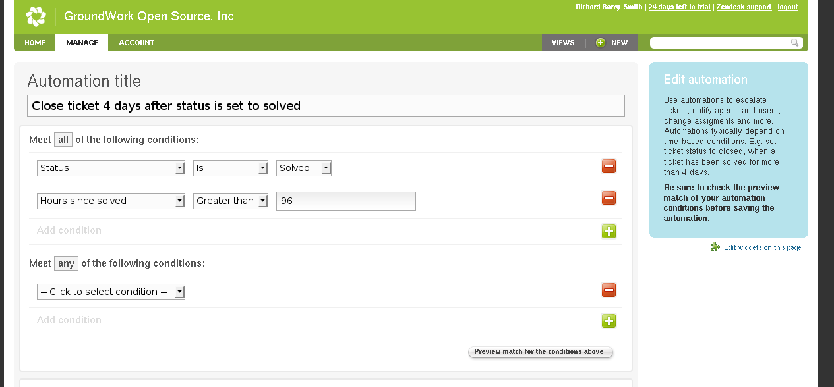

## SECTION 3 – KNOWN ISSUES AND LIMITATIONS

|  |  |
| --- | --- |
| **Reference** | **Summary** |
| GWMON-8413 | User session timeout message may be seen in the Zendesk application after a period of inactivity. The reload button is provided to restart the session. |
| GWMON-8383 | When multiple events are selected in the event console both events are tagged with the ticket number, only the last event is imported into the Zendesk ticket. |
| GWMON-8381 | Generated links back to the GroundWork server may contain the address “127.0.0.1.” This address will be incorrect in some cases. |

## 